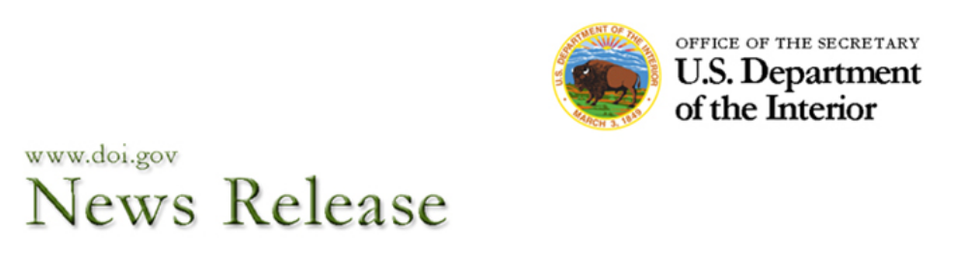
Date: April 8, 2014
Contact: Interior_Press@ios.doi.gov

Interior Signs Cooperative Agreement with Sisseton-Wahpeton Oyate as Next Step in Land Buy-Back Program

Sisseton-Wahpeton Oyate of Lake Traverse Reservation in North & South Dakota Join Latest Step in Nation-to-Nation Cooperation to Strengthen Tribal Sovereignty

WASHINGTON, DC – As part of President Obama’s commitment to help strengthen Native American communities, U.S. Secretary of the Interior Sally Jewell today announced the latest step in the implementation of the Land Buy-Back Program for Tribal Nations (Buy-Back Program), as the Department signed its next cooperative agreement, this time with the Sisseton-Wahpeton Oyate of the Lake Traverse Reservation located in northeastern South Dakota and in southeastern North Dakota.

This agreement provides resources to the tribal government to facilitate outreach and education, solicit interest from owners, and further support land research in the effort to consolidate fractionated lands for the beneficial uses of tribes. The Department expects to send offers to willing sellers with fractionated interests at the Lake Traverse Reservation later this year.

The Buy-Back Program was created to implement the land consolidation component of the Cobell Settlement, which provided $1.9 billion to purchase fractionated land interests from willing sellers and consolidate those interests across Indian Country. The Buy-Back Program allows interested individual owners to receive payments for voluntarily selling their land. Consolidated interests are immediately transferred to tribal governments where they stay in trust for uses benefiting the tribes and their members.

“We know that Nation-to-Nation cooperation and collaboration is the key to successfully implementing this historic opportunity to reduce fractionation and strengthen tribal sovereignty,” said Interior Secretary Sally Jewell. “We look forward to working with the Sisseton-Wahpeton Oyate to effectively reach landowners to communicate the importance of reducing fractionation, relay the advantages of consolidating their land for the beneficial uses of their tribe, and provide the resources available to them for more information.”

Interior holds about 56 million acres in trust for American Indians in more than 200,000 tracts. Of those, nearly 94,000 – on about 150 reservations – have multiple and in some cases numerous owners who each hold a fractional interest available for purchase by the Buy-Back Program. The fractionation of tribal lands over generations has locked away resources and prevented effective land-use decision making by tribes. Fractionation has made it increasingly difficult for tribes to manage this land for economic development and other uses.

The Buy-Back Program is now working to consolidate these fractionated lands and restore them to the tribe of jurisdiction, which helps make sure that Indian lands stay in trust. The tribe can then use this land to benefit its community – for example, to build homes, community centers or businesses, or for cultural or environmental preservation.

“The Sisseton-Wahpeton Oyate of the Lake Traverse Reservation has been actively acquiring fractionated lands for over three decades in an effort to reduce fractionation on the reservation,” said Tribal Chairman Robert Shepherd. “The Cobell Land Buy-Back Program will further our efforts to acquire more fractionated lands, increase the tribal land base and significantly decrease further fractionation for our children and future generations. Our previous and continued efforts are made in the spirit of our inherent tribal sovereignty and as a means of self-determination.”

Approximately 90 percent of all of the fractionated lands available for purchase are in 40 of the 150 locations eligible to participate in the Buy-Back Program under the Cobell Settlement. The Program’s goal is to reach as many of these locations as possible. Since December of last year, the Program has already returned more than 30,000 acres to tribes.

Interior expects to enter into additional agreements in the coming months. Through an open solicitation from November 2013-March 2014, the Department received more than 50 letters of interest or cooperative agreement applications for participation in the Program. Outreach, mapping and mineral evaluations are already occurring at many locations.

Sellers receive fair market value for their land, in addition to a base payment of $75 per offer, regardless of the value of the land. All sales will also trigger contributions to the Cobell Education Scholarship Fund. Up to $60 million will go to this fund to provide scholarships to Native American students. These funds are in addition to purchase amounts paid to individual sellers, so contributions will not reduce the amount paid to landowners for their interests. The Scholarship Fund is administered by the American Indian College Fund in Denver, Colorado, with 20% going to the American Indian Graduate Center in Albuquerque, New Mexico.

There are a number of steps that tribal governments can take now to prepare for involvement in the Buy-Back Program, including increasing owner awareness and designating a tribal point of contact to engage with the Program. Details are online at: http://www.doi.gov/buybackprogram/tribes/preparation.cfm.

Landowners with interests on the Lake Traverse Reservation can contact the Trust Beneficiary Call Center at (888) 678-6836 to get more information about the potential to sell land so that it can be returned to the tribe or to register their information. Additional information is available at: http://www.doi.gov/buybackprogram/landowners.

###

