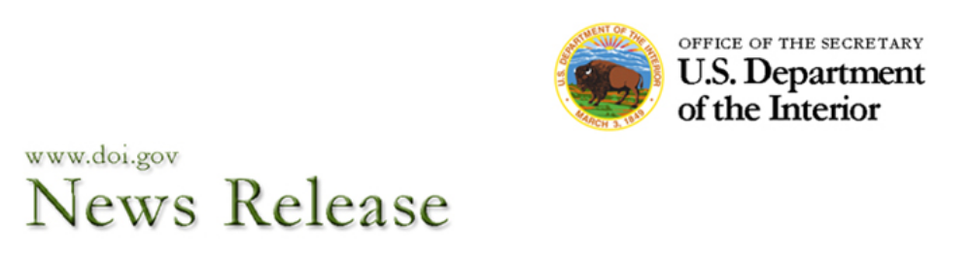
Office of the Assistant Secretary – Indian Affairs

FOR IMMEDIATE RELEASE CONTACT: Nedra Darling
November 26, 2013 202-219-4152

Black Names Weldon “Bruce” Loudermilk
as BIA’s Next Regional Director for Alaska

WASHINGTON – Bureau of Indian Affairs Director Michael S. Black has named Weldon “Bruce” Loudermilk as Regional Director of the Bureau of Indian Affairs’ Alaska Regional Office in Anchorage. Loudermilk, an enrolled member of the Assiniboine and Sioux Tribes of the Fort Peck Indian Reservation in Montana, had been serving as regional director of the Bureau’s Great Plains Regional Office in Aberdeen, S.D., since June 20, 2010.

“We recognize the importance of identifying and hiring the best candidates to serve tribes, the Alaska Native people and Alaska Native Corporations,” said Assistant Secretary – Indian Affairs Kevin K. Washburn. “Given that BIA regional directors are responsible for ensuring Indian Affairs carries out its mission within their regions, it is my firm belief that we should always be working to attract the best and brightest to these positions.”

“I have full confidence in Bruce Loudermilk’s commitment to our mission of serving all of the federally recognized tribes in Alaska,” said Black. “He will bring his vast amount of administrative and management experience to the Alaska Regional Directorship, and strengthen our government-to-government relationship with the Alaska Native tribes.”

“I am committed to carrying out our trust responsibilities to the Alaska Native tribes and individual trust beneficiaries,” Loudermilk said. “I look forward to working with Assistant Secretary Washburn and his team and with the Alaska Native leadership to improve the BIA’s delivery of services to the tribes and villages throughout the Alaska Region.”

The Alaska Regional Office oversees two agencies serving 229 federally recognized Alaska Native tribes and villages, except the Metlakatla Indian Community of the Annette Islands Reserve.

While serving as the Great Plains Regional Director, Loudermilk was temporarily appointed as the Acting Deputy Assistant Secretary – Indian Affairs for Management in the Indian Affairs

-Continued-
Loudermilk – Page 2

headquarters office in Washington, D.C., from Oct. 3, 2011, to Sept. 25, 2012. Upon completion of that assignment, he returned to the Great Plains Regional Office.

Prior to becoming acting Great Plains Regional Director, Loudermilk had served since March 2, 2008, as the Great Plains Deputy Regional Director – Indian Services, where he provided programmatic oversight in the areas of self-determination, human services, tribal government, transportation, housing, environmental, safety and cultural resource management.

Loudermilk began his 23-year federal career in May 1990 in the transportation division of the Bureau’s Billings (Montana) Area Office (now Rocky Mountain Regional Office). Prior to becoming the deputy regional director, he served in the Interior Department’s Office of the Special Trustee for American Indians (OST) as a Financial Trust Services Officer (May 1998-June 2005) and as a Fiduciary Trust Officer (July 2005-March 2008), both of which were also located in the Rocky Mountain Regional Office.

During his tenure with OST, Loudermilk helped carry out the Department’s responsibility for Indian trust management by providing fiduciary trust oversight for tribal and individual Indian money accounts (IIMs). He also provided leadership in defining OST’s fiduciary trust management roles and responsibilities through the development and implementation of regulations, policies and procedures at agency, regional and national levels.

Loudermilk also brings private sector experience from the financial services, energy (oil and gas) exploration and petroleum technology industries. In 2006, Loudermilk received his designation as a Certified Indian Fiduciary Trust Specialist from the Cannon Financial Institute of Athens, Ga., a provider of professional development and training to the financial services industry.

Loudermilk holds a Bachelor of Science degree in Business Administration from what is now Montana State University-Billings (1989). He is a graduate of the DOI’s Senior Executive Service Candidate Development Program, Class #14 (May 2006).

The process for selecting the Alaska Regional Director was exhaustive and Indian Affairs twice advertised the position. In an effort to expand the pool of eligible candidates, the second solicitation for applications was extended to five weeks. The Bureau also recognized that a potential hurdle for candidates may have been unfamiliarity with the federal hiring process for Senior Executive Service (SES) employment. To better prepare potential candidates, who were unfamiliar with the SES hiring process, Indian Affairs offered a training session in Alaska, along with a webinar, to educate and assist potential applicants with the SES process. The Bureau also consulted with tribal leaders regarding the candidates.

The Alaska post is one of 12 regional directorships who manage the BIA’s regional offices, oversee numerous agencies directly serving federally recognized tribe and communities across the country. All of the regional director positions are SES-level appointments and report to the director of the BIA.

-Continued-

Loudermilk – Page 3

The Assistant Secretary – Indian Affairs oversees the BIA, which is headed by a director who is responsible for managing day-to-day operations through four offices – Indian Services, Justice Services, Trust Services and Field Operations – that administer or fund tribally based infrastructure, law enforcement, social services, tribal governance, natural and energy resources and trust management programs for the nation’s 566 federally recognized American Indian and Alaska Native tribes and villages through 12 regional offices and 85 agencies.

Note to Editors: A photo of Weldon “Bruce” Loudermilk may be viewed via the Indian Affairs website at http://www.bia.gov/WhoWeAre/AS-IA/OPA/Photo/index.htm.

-DOI-

