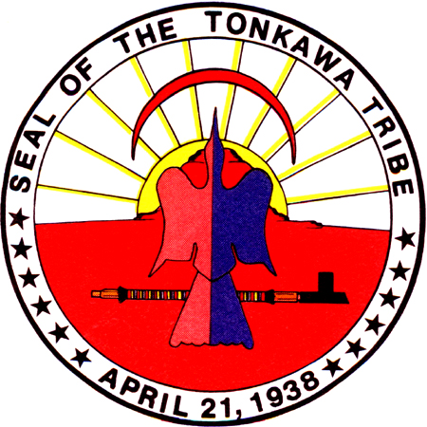

TONKAWA TRIBE OF OKLAHOMA

TONKAWA TRIBAL COMMITTEE
1 RUSH BUFFALO ROAD • PHONE (580) 628-2561 • FAX (580) 628-3375
WEB SITE: www.tonkawatribe.com
TONKAWA, OKLAHOMA 74653

Date Posted: October 9, 2017

THE TONKAWA TRIBE IS ACCEPTING APPLICATIONS/RESUMES FOR A
SUBSTANCE ABUSE PROGRAM DIRECTOR

TITLE: SUBSTANCE ABUSE PROGRAM DIRECTOR
SUPERVISOR: EXECUTIVE DIRECTOR

GENERAL DESCRIPTION:
The Substance Abuse Program (SAP) Director is in charge of managing and operating the Substance Abuse Program with services including, but are not limited to, assessment, treatment planning, individual and group therapy for clients and their families, educational presentations, and therapeutic interventions.

DUTIES AND RESPONSIBILITIES:
- Establishes program policy and procedure
- Manage and administers the staff and resources of the Substance Abuse Program
- Be responsible for collecting and analyzing all data, meeting all objectives, and
evaluate outcomes
- Trains and empowers staff to provide quality programming to serve clients
- Prepares project reports for funding agencies and Tribe
- Attend all required in-state and out-of-state training
- Will raise awareness, reduce stigma, and be a resource to the community
- Must have the ability to provide teaching, training, and counseling with patience and understanding.
- Must possess a helpful attitude and understand the problems of the chemically dependent person and have extensive knowledge of methamphetamine addiction, and suicide prevention.

QUALIFICATIONS:
A minimum of the following will be required:
- BS Degree and/or A.A./A.S. in Addiction Studies or Behavioral Sciences
- Certified as a Counselor through I.A.C.C., C.A.A.D.A.C., C.A.A.R.R. or C.A.A.D.E.
- Two (2) years’ work experience in A/OD field as a Certified Counselor I or better
- Must have a strong clinical background, including experience in interviewing and therapeutic techniques; human development, psycho-dynamics; family systems and pharmacology.
- Must have computer skills, experience with statistics, report writing experience, meeting coordination, scheduling, knowledge of mental health services
- A background check is required and must have valid Driver’s License and insurance.
- Submit to random drug testing.
- Must adhere to strict confidentiality

Applications available at HLA Building.
Tonkawa Tribe and Native American preference do apply.

