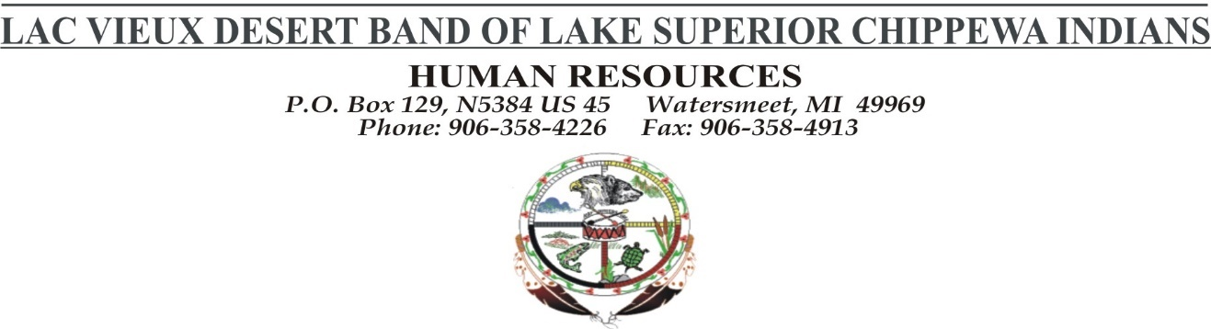
JOB DESCRIPTION
POSTED: JUNE 27, 2018 DEADLINE: UNTIL FILLED
POSITION: General Counsel
DEPARTMENT: Tribal Government
LOCATION: Lac Vieux Desert Tribal Administration Office
EMPLOYMENT: Full time
SALARY/PAY RATE: TBD
DESCRIPTION:
Under the direction of the Tribal Council to the Lac Vieux Desert Band of Lake Superior Chippewa Indians (“LVD” or “Tribe”), the General Counsel provides legal services and representation to the Tribe, its agencies, and its enterprises in all areas of law. Frequent travel is required.
RESPONSIBILITIES:
- Provide legal representation for the Tribal Council, subordinate tribal boards and committees, governmental departments and agencies, and tribal enterprises regarding the tribal governmental and business affairs;
- Assume ultimate control, responsibility, and authority for all legal affairs of the General Counsel’s Office, including all attorneys and support staff, outside counsel, the department budget, etc.
- Negotiate and draft intergovernmental agreements, contracts for services and goods, and commercial development agreements;
- Litigate at the trial and appellate levels in federal, state, and tribal courts and in administrative and private forums;
- Draft tribal legislation, resolutions, administrative rules and regulations, charters and other documents and instruments to establish and develop governmental and commercial entities;
- Assist with the creation, development, and amendment of tribal regulations and coordinate with federal, state, and local counterparts;
- Monitor federal, state, and local legislation and political affairs, report on matters of interest to tribal leadership, and provide advice regarding proper possible responses and courses of action;
- Assist in protecting and asserting the rights of the Tribe under the Native American Graves Protection and Repatriation Act, the National Historic Preservation Act, the Archeological Resources Protection Act and other federal and state laws to preserve the cultural resources of the LVD community and related indigenous groups;
- Assist with personnel issues, employment disputes and other personnel matters and work with the tribal leadership regarding the development of policies and procedures for implementing improvements in human resource management;
- Assist LVD Band in its efforts to fulfill its governmental responsibilities regarding environmental protection and coordinate with federal, state, and local environmental agencies regarding tribal environmental concerns.
The responsibilities listed above are representative of the nature and level of work assigned and are not.
MINIMUM QUALIFICATIONS:
- 3-5 years experience as a practicing attorney in one or more legal fields relevant to the General Counsel’s duties;
- Licensed and member in good standing of the State Bar of Michigan or must become licensed with the State Bar of Michigan within one (1) year of employment start date;
- Demonstrate high academic achievement in law school with a 3.0 g.p.a. or higher;
- High level of written and oral communication skills and superior ability to advocate and persuade;
- Exceptional ability to think on feet to identify and analyze legal issues and present legal theories;
- Willingness to accept unusual and challenging assignments and an ability to identify successful strategies to obtain desired result;
- Highly independent and organized and able to manage significant number of active matters simultaneously;
- Demonstrated commitment to work the hours necessary to maintain deadlines;
- Well developed interpersonal skills and ability to work in a supportive and professional manner with other attorneys, support staff and client agencies;
- Professional demeanor, appearance and enthusiasm for the law and public service;
- Thorough knowledge of and commitment to professional ethics, particularly those rules that relate to the representation of governments and other organizations;
- Excellent references with substantial personal knowledge of applicant’s legal abilities;
- Proficiency in legal research techniques, superior electronic and library research skills, and thorough knowledge of legal resources;
- Proficiency in Microsoft Office programs and other word processing and document preparation programs;
- Valid state driver’s license and able to meet minimum insurance requirements to use GSA vehicles; and
- Must pass criminal background check and drug screening.
PREFERRED QUALIFICATIONS:
- Demonstrated commitment to Indian affairs as shown through significant experience working with Indian tribes or programs specific to Indian affairs;
- Wisconsin Bar License in addition to a Michigan Bar license.

The above statements are intended to describe the general nature and level of work performed by people assigned to this classification. They are not intended to be construed, as an exhaustive list of all responsibilities, duties and skills required of personnel so classified. Management retains the right to add or to change the duties of the position at any time. Must be able to pass a pre-employment drug screen and applicable background checks related to the position.
Date Approved by the Tribal Council:

