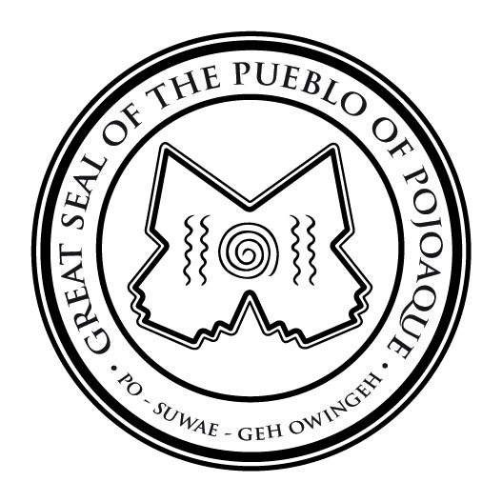
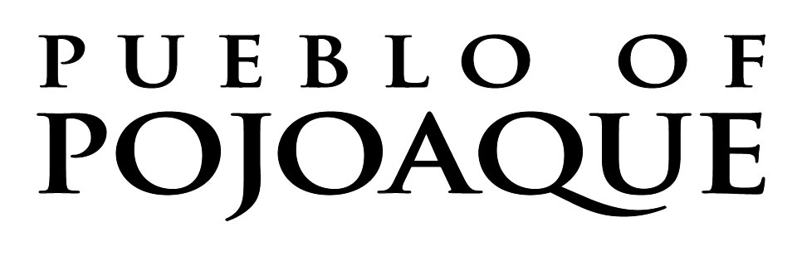

OFFICE OF THE GOVERNOR
78 CITIES OF GOLD ROAD
SANTA FE, NEW MEXICO 87506
(505) 455-3334 FAX (505) 455-3684

CHIEF GENERAL COUNSEL

SUPERVISED BY: Tribal Governor

POSITION DESCRIPTION:
The Pueblo of Pojoaque Legal Department is the principal legal counsel of the Pueblo of Pojoaque and provides professional legal counsel and representation to the Pueblo’s Tribal Council, elected Officials, departments, agencies, boards and commissions, tribal members, and the Pueblo’s various businesses as specified by the Tribal Council. Serving at the pleasure of the Governor and Tribal Council, the Chief General Counsel and all General Counsels perform a full range of legal services requiring substantial knowledge and understanding of the Pueblo, its departments and businesses, and a general understanding of Indian law and tribal-federal-state relationships.

The successful candidate must be able to handle high pressure situations and have demonstrated experience handling confidential matters.

The Chief General Counsel must consistently demonstrate the ability to analyze difficult and complex facts and issues, and to issue clear oral and written decisions in a timely manner. The successful candidate must have excellent organizational skills, independent thought, and strong research and writing skills.

QUALIFICATIONS:

To perform this job successfully, an individual must be able to perform each of the locally established essential functions and meet the minimum education and experience qualifications described below satisfactorily. The requirements listed are representative of the knowledge, skill, and ability required for a Chief General Counsel. It does not restrict the Pueblo’s right to assign or reassign duties and responsibilities for this job at any time.

The successful candidate must be able to comply with the Pueblo of Pojoaque employment policies, including pre-employment drug screening.

I. Job Duties

The Chief General Counsel job duties include, but are not limited to:

- Oversight of and responsibility for all executive, managerial, and administrative duties of the Legal Department, including hiring and management of employees, establishing budgets, document control, client relations, litigation, and outside legal contracts.
- Represent, or oversee legal representation of, the Pueblo government, its business enterprises, non-profits entities, and Boards and Commissions in legal disputes, court actions, administrative, and legislative hearings, and any related activities such as mediation, settlements, arbitration, and litigation.
- Provide legal advice to the Tribal Officials as the Executive body and the Tribal Council as the Legislative body of the Pueblo government.
- Assist Tribal government and corporate entities with development of policies and procedures.
- Develop processes and procedures for effective and efficient legal representation of the various Pueblo government departments, corporate entities, Boards and Commissions.

II. Education, Experience and Qualifications.

In entering into this agreement, the Employee warrants and represents that he meets the minimum requirements of the position, including:

1. Juris Doctorate from an accredited law school and licensed to practice law in one or more jurisdictions in the United States and will become a member of the New Mexico Bar within one (1) year of date of employment.
2. At least fifteen (15) years of legal practice, including at least ten (10) years as a principal of a law firm and/or managing a corporate or government legal department supervising attorneys and staff.
3. Demonstrated knowledge of relevant areas of Indian law, including gaming and sovereignty, self-governance and sovereign immunity, and of business law, including employment and contracts.
4. Demonstrated expertise in complex commercial transactions, including finance, acquisitions, and development, and in advising leadership regarding Tribal governance and policy.
5. Skilled at analyzing and interpreting laws, including for risk assessment and mitigation, and in strategizing for legal proceedings to protect the Tribe’s legal rights.
6. Strong analytical skills to review and create solutions for complex issues.
7. Exceptional oral and written communication skills, interpersonal skills and mediation skills.
8. Ability to work independently and as a member of a team, including a member of the Tribe’s senior executive team.

9. Ability to successfully lead and develop attorneys and professional staff as well as evaluate legal competencies.

DESIRABLE QUALIFICATIONS:
- Experience working with Native Americans and Tribal Governments.
- Knowledge of Pueblo of Pojoaque Law and Order Code, court procedures and rules of court.
- Knowledge of tribal customs and traditions.
- Proficiency in Microsoft Office, including Word and Outlook.

CONTINUED PERSONAL PROFESSIONAL DEVELOPMENT:

- Comply with Pueblo-wide and department personnel procedures and policies.
- Participate in applicable job-related trainings, including maintaining CLE requirements for state licensure.

PHYSICAL, MENTAL AND ENVIRONMENTAL DEMANDS:
- May require extended hours and occasional travel.
- Manual dexterity to operate computers and other necessary office equipment.
- Able to work in a fast-paced, multi-task environment.
- Able to bend, reach, kneel, twist and grip items in assigned work area.

WORK ENVIRONMENT:
Work is generally performed within an office environment with standard office equipment available. Work is generally sedentary in nature but may require standing and walking for up to 10% of the time. The working environment is generally favorable. The noise level in the work environment is usually moderate. Lighting and temperature are adequate and there are no hazardous or unpleasant conditions caused by noise, dust, etc. Work may include highly stressful situations at times.

