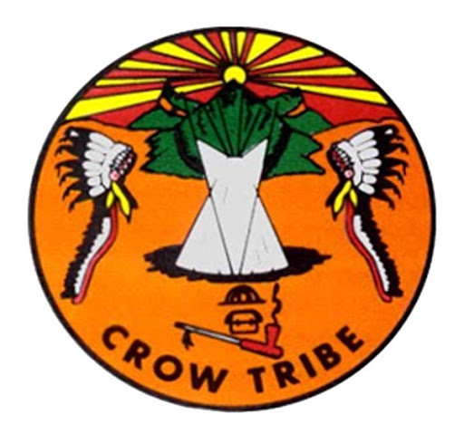

Executive Branch of the Apsáalooke Nation
Post Office Box 159
Crow Agency, Montana 59022
Ph. 406-679-4047

Frank White Clay,
CHAIRMAN
Lawrence DeCrane,
VICE CHAIRMAN
Levi Black Eagle,
SECREATARY
Channis Whiteman,
VICE SECRETARY

Office Of Personnel

JOB OPENING

Crow Tribal Education Program is accepting applications: Johnson O’Malley Coordinator
This position is primarily responsible for the overall coordination of the Johnson O/Malley program for the Crow Tribal Administration.

Deadline: Open Until Filled

Job Duties: This position is responsible for coordinating and administering the Johnson O’Malley program with schools. Work is performed in an office setting during normal business hours. Travel to attend meetings and conferences. This position requires skills and be knowledgeable in the use of a computer and various office equipment. Must be able to write quarterly reports and an annual report for JOM.
Supervisor will be the education director.

Education: A minimum of an Associates Degree and or five (5) years of experience in an educational field preferably related to counseling, teaching, and/or education program administration.

