Pokagon Band of Potawatomi Indians
Stormwater and Wastewater Asset Management Plan

Request for Proposal

Pokagon Band of Potawatomi Indians
Department of Natural Resources
58620 Sink Rd
Dowagiac, MI 49047
269-462-4268

Instructions

1. Description.

The Pokagon Band of Potawatomi Indians (“Pokagon Band”) is a federally recognized Indian tribe with a ten-county service area in southwest Michigan and northern Indiana. The Pokagon Band is soliciting proposals from a qualified engineering firm to develop an asset management plan for Stormwater and Wastewater Systems located on the Rodgers Lake Campus. Depending on funding, an alternate site inclusion of the Crystal Springs Property may be possible.
In this Request for Proposal (“RFP”), the Pokagon Band seeks sealed proposals from individuals and legal entities to complete this Work in accordance with the attached Exhibit A - Statement of Work. Development of a proposal for the Rodgers Lake Campus with a secondary sub-proposal for the Crystal Springs property, if funding allows for additional work to be completed.

2. Contents.

Proposals must be in accordance with this RFP, including without limitation, addressing all requirements of Exhibit A - Statement of Work. Proposals also must include a cover letter summarizing the proposal, which must certify that the signatory is legally authorized to commit the proposer to all terms and conditions of the proposal. Each proposer must complete, sign, and submit with the proposal the attached Exhibit B – W-9 Form.

Proposers are discouraged from including any information in a proposal that may be considered confidential or proprietary under applicable law. If a proposal must include such information, then a proposer must specifically designate the specific portions of the proposal that are confidential or proprietary. The Pokagon Band will treat such information as confidential, but neither the Pokagon Band nor any of its officials, employees or representatives shall be responsible for any release of such information.

3. Specifications.

The selected proposer, by virtue of submitting the name and specifications of a manufacturer's product, shall be required to furnish the named manufacturer's product, unless the Pokagon Band, at its sole discretion, agrees otherwise in writing.

4. Fee.

Proposals must state all amounts to be charged in connection with completing the Work and must state all expenses for which the proposer will seek reimbursement, including without limitation, separately stating all fees and costs for each component of the work listed in Exhibit A – Statement of Work. Any discounts shall be incorporated as a reduction in the proposal price and not shown separately. The price, as shown on the proposal, shall be the price used in determining awards. Proposers are solely responsible for all costs and expenses which are incurred in connection with preparing and submitting a proposal.

5. Identity.

Proposals must state the legal name, address, and telephone of the proposer and whether the proposer is an individual or entity and, if an entity, the type of entity (corporation, limited liability company, partnership, etc.). Proposals must be signed above the typed or printed name and title of the signer, who must be authorized to bind the proposer to the proposal.

6. Licenses.

Proposers must possess all necessary licenses and comply with all applicable legal requirements to perform the Work at the time of submission of a proposal. The failure to meet such requirements shall constitute grounds to reject a proposal.

7. Submission.

Proposals must be submitted by email to Michael Engen (“Purchasing”) at michael.engen@pokagonband-nsn.gov.

8. Deadline.

Proposals must be received by Purchasing no later than 5:00 P.M. on February 3rd, 2023 (“Deadline”). Purchasing will date and time stamp each proposal. Each proposer is solely responsible to for ensuring that a proposal is received by the Deadline. Telephone confirmation of receipt of the proposal may be made by calling Purchasing at (269) 462-4268.

9. Clarification.

Proposers must examine this RFP and all related documents and judge all matters relating to the adequacy and accuracy of the same. Any inquiries, suggestions, or requests concerning interpretation, clarification or additional information regarding this RFP (“Request”) must be made to Purchasing not less than one (1) week prior to the Deadline.

In response to a Request, Purchasing may issue a written addendum to this RFP, which shall be the only official method for providing interpretation, clarification, or additional information. Proposers are solely responsible for contacting Purchasing to determine whether any addenda have been issued.

Neither the Pokagon Band nor any of its officials, employees or representatives shall be responsible for any verbal response provided in connection with a Request. The Pokagon Band reserves the right to request additional information from a proposer and to request a verbal presentation from a proposer.

10. Recording.

All proposals which are timely received shall be recorded by Purchasing. A public opening of proposals will not occur.

11. Irrevocable.

Any proposal may be withdrawn before the Deadline. Any proposal not timely withdrawn shall constitute an irrevocable offer for a period of 120 days to perform the Work in accordance with Exhibit A - Statement of Work, which may be accepted by the Pokagon Band through issuance of a notice of award to the selected proposer.

Proposal modifications will be accepted only if received prior to the Deadline, in writing, properly signed by the authorized representative of the proposer. Proposal modifications shall be submitted in the same manner as a proposal but shall be clearly marked as “Modification to Proposal for Stormwater and Wastewater Asset Management Plan”.

Any mathematical errors contained within a proposal shall be corrected by the Pokagon Band, including without limitation, misplaced decimal points or discrepancies between unit prices and extended prices, etc.

12. Evaluation.

The Pokagon Band will select the proposal that it determines to be most advantageous to the Pokagon Band. The Pokagon Band will determine whether a proposal meets the requirements of this RFP and, depending on the nature of the requirement, may eliminate a proposal for failure to comply with one or more of the requirements of this RFP.

13. Reserved.

The Pokagon Band reserves the right to reject all proposals, to waive variances or deficiencies in any proposal, to abandon the project, or to re-solicit other proposals for the project on such terms as the Pokagon Band deems appropriate. The Band may, at its discretion, waive any formalities or irregularities contained in a proposal or in the manner of its submittal and award a contract. This RFP does not create any obligation which is legally enforceable against the Pokagon Band or any Pokagon Band official, employee or representative.

14. Contract.

The Pokagon Band anticipates entering into a contract in connection with this RFP, which shall be in a form and substance substantially similar to Exhibit C - Services Agreement, unless the Pokagon Band, in its sole discretion agrees otherwise. This RFP is not a contract offer and any proposal submitted in response to this RFP shall not constitute a contract with the Pokagon Band. A contract between the Pokagon Band and a proposer shall not be established until the Pokagon Band has fully reviewed all proposals and a written contract that clearly sets forth all material terms and conditions of agreement has been duly authorized and approved by the Pokagon Band and the selected proposer. If the Pokagon Band and the selected proposer are unable to finalize a contract with terms and conditions that are acceptable to the Pokagon Band, then the Pokagon Band may elect to accept another proposal or re-solicit additional proposals through a new RFP or other process.

The selected proposer must complete all forms required by the Pokagon Band, including without limitation, Exhibit D – Acknowledgement of National Sex Offender Registry Check Form.

15. Compliance.

Proposers must comply with, and proposals are subject to, all applicable laws, rules, regulations, and standards in connection with the Work, including without limitation, all requirements which apply in connection with the Pokagon Band using any grant to fund the Work, whether in whole or part. By submitting a proposal, each proposer acknowledges and agrees to all terms and conditions of this RFP.

Exhibit A - Statement of Work

Background
The Pokagon Band owns a wide array of wastewater assets including simple septic systems, community collection and treatment systems, with lagoons, biofilters and recirculating sand filter systems. Further, the Band owns a wide variety of stormwater assets including culverts, stormwater collections systems, bioswales, green roofs, rain gardens, infiltration basins, retention basins, drains, ponds, and other stormwater treatment structures. These assets vary in age from new to over 50 years old. The condition, value, useful life, and criticality of the assets are currently unknown. The Band desires to have a Stormwater and Wastewater Asset Management Plan developed to address the aforementioned project goals to fulfill a need and maintain or enhance the quality of surface water.

Project Goals
In general, this project, located on the Dowagiac Rodgers Lake Tribal Government campus with Crystal Springs Property alternate includes but is not limited to, the following:

1. Asset Inventory and Conditional Assessment
2. Level of Service
3. Criticality of Assets
4. Operation and Maintenance Strategies
5. Revenue Structure and Long-Term Funding needs for Maintenance and Capital Improvements
6. Implementation Plan

Scope of Work
Task 1: Asset Inventory and Conditional Assessment
- Educational meetings will be held with elected officials, staff and public to discuss the value of the proposed work plan as well as throughout the development of the plan. A mission statement for the implementation of the asset management plan will be developed. Clear expectations for the implementation of the work plan will be established.
  - Work closely with key members of tribal departments including Housing & Community Development, Information Technology, Facilities, and Natural Resources
- Asset inventory and mapping
  - Review existing data and develop a database for proposed and future data. Incorporate Band's existing property data for base mapping.
  - Obtain and scan copies of all system drawings and documents to map and manage system, to include record drawings, shop drawings, operation, and maintenance manuals.
    - Review current inventory of scanned files and determine what additional drawings or documents are needed for the assessment
  - Develop GIS based inventory and mapping for the stormwater and wastewater system using digitized scanned copies of system drawings and documents, aerial photography, and parcel information provided by the Band. Coordinate the acquisitions of hardware and setup of software to view, edit and manage the system data.
    - Work with GIS Specialist and Planning Manager to coordinate efforts and determine what GIS inventory currently exists and what needs to be yet developed.
  - Provide inventory list of major assets identified.
  - Provide orientation to staff for the use of the GIS and asset management information.
- Determine Band needs for Asset Management Hardware and Software
  - If hardware and software needs are identified, work closely with Information Technology to vet safety and security as well as determine installation needs.
  - Work closely with GIS Specialist to determine needs for Asset Management Hardware and Software.
- Determine condition of stormwater and wastewater assets
  - Provide details regarding life expectancy and remaining life of the assets.
  - Determine functionality of current stormwater and wastewater assets to provide recommendations on regular maintenance and additional needs that are identified.
- Determine if PACP and MACP training certification would be beneficial for Band employees to acquire.
- Determine asset values and replacement costs for all assets.

Task 2: Level of Service
- Complete a short- and long-term capacity analysis. Evaluate current flows and capacities of major collection and treatment components.
- Review records for regulatory compliance.
- Evaluate and identify the required reliability of service.

Task 3: Criticality of Assets
- Determine the criticality of all assets along with the likelihood, consequence, and cost of failure.
  - Establish criteria for determining probability and consequences of failure with the incorporation of future climate change scenarios
  - Calculate criticality for each asset and rank assets based on condition and identified risk tolerance.
  - Determine the need for redundancy and identify weaknesses within current systems.

Task 4: Operation and Maintenance Strategies
- Review the operation and maintenance practices and recommend changes to improve efficiency.
- Review contracts for significant service providers.
- Recommend preventative maintenance plans, where appropriate.
- Complete an energy efficiency evaluation for major components or processes and recommend improvements to reduce long-term costs.
- Evaluate lifecycle costs for major assets.

Task 5: Capital Improvement Planning
- Identify strategic capital improvements, costs, schedule, and potential funding sources.

Task 6: Revenue Structure and Long-Term Funding
- Identify required revenues for long term OM&R and strategy to finance future capital improvements. Recommend changes in budgeting and funding methodology to meet requirements of SAW Grant.

Task 7: Implementation Plan
- Identify steps and schedule to implement the plan.

Alternate:
    - The Alternate site of Crystal Springs will cover all the same tasks as the main project.

    - Alternate Definition: An amount proposed by bidders and stated in the proposal for work defined within Crystal Springs that may be included within the overall project dependent upon secured funding. A contractor may decide not to bid on the alternate site.

Document Examination and Procurement
This Request for Proposal will be available beginning January 6th, 2023 and may be examined at the following internet link: Request For Proposal (RFP) - Stormwater and Wastewater Asset Management Plan.

Prequalification
Each bid must be accompanied by a list of at least three projects completed within the last 5 years that demonstrates expertise in any of the following areas of work: 1) Stormwater Asset Management Planning 2) Wastewater Asset Management Planning 3) Combined Stormwater and Wastewater Asset Management Planning. Each project shall include associated description, cost, and reference, including telephone number.

Work Location
The Pokagon Band Rodgers Lake Campus is in Cass County, Dowagiac, Michigan near M51 (Figure 1).
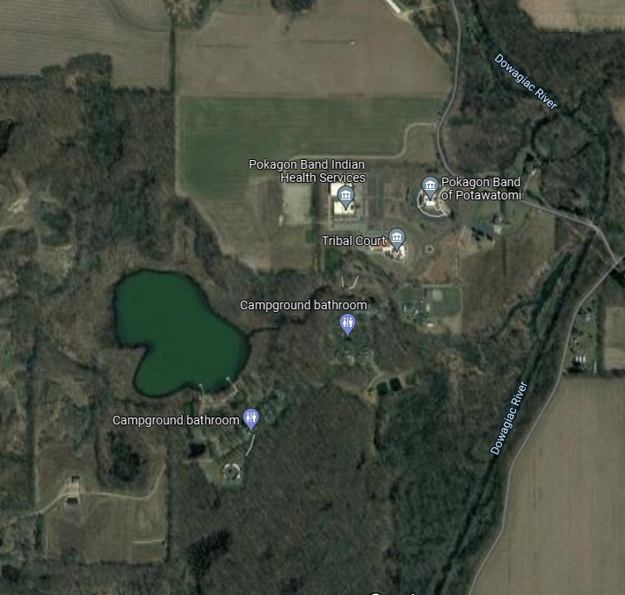

Figure 1. Pokagon Band Rodgers Lake Campus general overview.

Schedule
- The RFP must include a schedule with the number of calendar days that it will take for the proposer to complete each stage of the Work and to achieve the deliverables.
- The schedule must identify any contingencies that may impact the proposer’s ability to meet the schedule.
- Given that projects will likely be completed over the next five years, proposals should include estimates of costs predicted at current costs, 2 and 5 years out based on the market and knowledge of similar projections for similar projects.

Payment Terms
33/33/33: With 33% to be paid upon contract finalization, 33% as determined during project progress, and 33% paid upon completion of the plan and acceptance by the Pokagon Band.
Basis of Bid
Bidder will complete the Work in accordance with the Request for Proposal for the following price(s):

Main Site: Rodgers Lake Campus
NO. | ITEM |  | TOTAL ESTIMATED PRICE
Task 1 | Asset Inventory and Conditional Assessment
Task 2 | Level of Service
Task 3 | Criticality of Assets
Task 4 | Operation and Maintenance Strategies
Task 5 | Capital Improvement Planning
Task 6 | Revenue Structure and Long-Term Funding
Task 7 | Implementation Plan
Total Base Bid
Alternate Site: Crystal Springs
NO. | ITEM |  | TOTAL ESTIMATED PRICE
Task 1 | Asset Inventory and Conditional Assessment
Task 2 | Level of Service
Task 3 | Criticality of Assets
Task 4 | Operation and Maintenance Strategies
Task 5 | Capital Improvement Planning
Task 6 | Revenue Structure and Long-Term Funding
Task 7 | Implementation Plan
Total Alternate Site Bid

